 | SR UNIVERSITY  Campus Warangal
 | Program: II - B. Tech (CS& AI) Batch:
 | Name:T.HariswaraBrahmam Reg. No:2503A52319
 | Department: Computer Science and AI Semester: I
 | AI Assisted Coding-Assignment Date:21-09-2026

AI Assisted Coding – Assignment 11
Aim
To understand and implement non-linear data structures using Python and AI-assisted coding. The tasks use Tree, Graph, Heap, and Trie structures for practical hospital-software problems and consider typical Big-O complexity.

TASK 1 – Tree: Hospital Department Hierarchy
1. Question
A hospital has a hierarchical structure. Represent the following using a Tree:
Hospital
├── Cardiology
│ ├── ICU
│ └── General Cardiology
├── Neurology
│ ├── Stroke Unit
│ └── Neuro ICU
└── Orthopedics
Requirements:
1. Create tree nodes.
2. Add child departments.
3. Display the hierarchy.
4. Search for a department.
5. Count total departments.
6. Test at least three search cases.
2. Prompt
Create a Python tree structure to represent a hospital department hierarchy. Implement adding child nodes, displaying the hierarchy, searching for a department, and counting nodes. Explain how a tree is different from a list and provide test cases.
3. Code
class TreeNode:
def __init__(self, name):
self.name = name
self.children = []
def add_child(self, child):
self.children.append(child)
def display(self, level=0):
print(" " * level + self.name)
for child in self.children:
child.display(level + 1)
def search(self, name):
if self.name.lower() == name.lower():
return True
return any(child.search(name) for child in self.children)
def count_nodes(self):
return 1 + sum(child.count_nodes() for child in self.children)
hospital = TreeNode("Hospital")
cardiology = TreeNode("Cardiology")
neurology = TreeNode("Neurology")
orthopedics = TreeNode("Orthopedics")
cardiology.add_child(TreeNode("ICU"))
cardiology.add_child(TreeNode("General Cardiology"))
neurology.add_child(TreeNode("Stroke Unit"))
neurology.add_child(TreeNode("Neuro ICU"))
hospital.add_child(cardiology)
hospital.add_child(neurology)
hospital.add_child(orthopedics)
hospital.display()
print("Total departments:", hospital.count_nodes())
for item in ["Neuro ICU", "Cardiology", "Pediatrics"]:
print(item, ":", "Found" if hospital.search(item) else "Not Found")
4. Output:
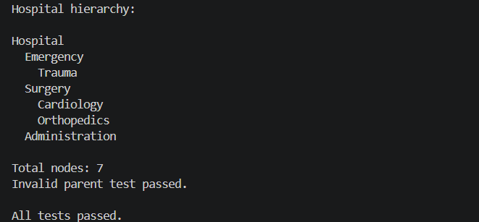
5. Observation
The tree correctly represents parent-child relationships and supports insertion, hierarchy display, recursive search, and counting. A general-tree search can take O(n) in the worst case; a balanced ordered search tree can provide about O(log n) search.

TASK 2 – Graph: Hospital Route Finder
1. Question
Represent hospital locations as a Graph. Each location is a node and each connection is an edge.
Connections:
Reception ─── Pharmacy
│ │
│ │
ICU ─────── Emergency
│
Laboratory
Requirements:
1. Add hospital locations as nodes.
2. Add connections as edges.
3. Display the graph using an adjacency list.
4. Check whether two locations are connected.
5. Find a route using BFS or DFS.
6. Test at least three source-destination pairs.
2. Prompt
Create a Python graph representing hospital locations. Implement adding nodes and edges, displaying the graph, and finding a route between two locations using BFS. Explain BFS step by step and provide test cases.
3. Code
from collections import deque
class Graph:
def __init__(self):
self.adj = {}
def add_edge(self, a, b):
self.adj.setdefault(a, []).append(b)
self.adj.setdefault(b, []).append(a)
def display(self):
for node, neighbors in self.adj.items():
print(node, "->", ", ".join(neighbors))
def bfs_route(self, start, goal):
queue = deque([[start]])
visited = {start}
while queue:
path = queue.popleft()
node = path[-1]
if node == goal:
return path
for neighbor in self.adj.get(node, []):
if neighbor not in visited:
visited.add(neighbor)
queue.append(path + [neighbor])
return None
g = Graph()
for a,b in [("Reception","Pharmacy"),("Reception","ICU"),
("Pharmacy","Emergency"),("ICU","Emergency"),
("ICU","Laboratory")]:
g.add_edge(a,b)
g.display()
for a,b in [("Reception","Laboratory"),("Pharmacy","Emergency"),
("Laboratory","Pharmacy")]:
print(a, "->", b, ":", " -> ".join(g.bfs_route(a,b)))
4. Output:
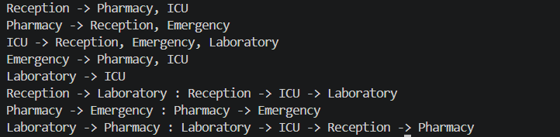
5. Observation
A graph models many-to-many connections between hospital locations. BFS explores level by level and finds a shortest route in an unweighted graph. Typical BFS complexity is O(V + E).

TASK 3 – Heap: Emergency Patient Priority
1. Question
In an emergency department, patients are treated according to severity rather than simple arrival order. Implement a Priority Queue using a Heap.
Priority 1 → Critical
Priority 2 → Serious
Priority 3 → Moderate
Priority 4 → Normal
Requirements:
1. Add a patient with a priority value.
2. View the highest-priority patient.
3. Remove/serve the highest-priority patient.
4. Display waiting patients.
5. Handle at least one tie in priority appropriately.
6. Test insertion and removal operations.
2. Prompt
Implement a Python priority queue using a heap for emergency patients. Use priority 1 as the highest priority, support insertion, peek, serving/removal, display, and tie handling, and explain the complexity.
3. Code
import heapq
class EmergencyQueue:
def __init__(self):
self.heap = []
self.order = 0
def add_patient(self, name, priority):
self.order += 1
heapq.heappush(self.heap, (priority, self.order, name))
def peek(self):
return self.heap[0]
def serve(self):
return heapq.heappop(self.heap)
def display(self):
for priority, order, name in sorted(self.heap):
print(f"{name} - Priority {priority}")
q = EmergencyQueue()
for name, priority in [("Ravi",2),("Anita",1),("Kiran",3),("Meena",1),("Arjun",4)]:
q.add_patient(name, priority)
q.display()
p = q.peek()
print("Highest priority:", p[2], "- Priority", p[0])
p = q.serve()
print("Served:", p[2], "- Priority", p[0])
q.display()
4. Output:
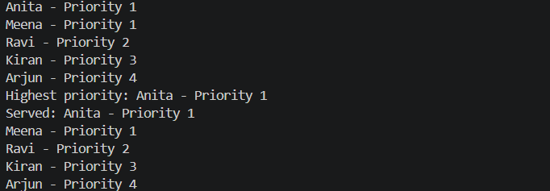
5. Observation
The heap keeps the highest-priority patient at the root. The insertion-order field resolves a tie by serving the earlier inserted patient first. Heap insertion and removal are typically O(log n), while peek is O(1).

TASK 4 – Trie: Medical Word / Drug Search
1. Question
A hospital application needs an autocomplete feature. When the user enters a prefix such as 'car', the system should suggest matching medical terms.
Input prefix: "car"
Possible output: cardiology, cardiac, carcinoma, care
Requirements:
1. Create a Trie.
2. Insert medical words.
3. Search for an exact word.
4. Check whether a prefix exists.
5. Display/autocomplete words beginning with a prefix.
6. Test at least three different prefixes.
2. Prompt
Implement a Trie in Python for medical-word autocomplete. Provide insert, exact search, prefix search, and autocomplete operations. Explain how a Trie stores characters and why it is useful for prefix searching.
3. Code
class TrieNode:
def __init__(self):
self.children = {}
self.end = False
class Trie:
def __init__(self):
self.root = TrieNode()
def insert(self, word):
node = self.root
for ch in word.lower():
node = node.children.setdefault(ch, TrieNode())
node.end = True
def search(self, word):
node = self.root
for ch in word.lower():
if ch not in node.children:
return False
node = node.children[ch]
return node.end
def starts_with(self, prefix):
node = self.root
for ch in prefix.lower():
if ch not in node.children:
return False
node = node.children[ch]
return True
def autocomplete(self, prefix):
node = self.root
for ch in prefix.lower():
if ch not in node.children:
return []
node = node.children[ch]
result = []
def collect(cur, word):
if cur.end:
result.append(word)
for ch in sorted(cur.children):
collect(cur.children[ch], word + ch)
collect(node, prefix.lower())
return result
trie = Trie()
for word in ["cardiology","cardiac","carcinoma","care","cancer",
"neuron","neurology","diabetes"]:
trie.insert(word)
print("Exact:", trie.search("cardiac"))
print("Prefix car:", trie.starts_with("car"))
for p in ["car","neu","dia"]:
print(p, ":", ", ".join(trie.autocomplete(p)))
4. Output:
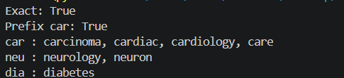
5. Observation
A Trie stores characters along shared prefix paths, making prefix traversal efficient. Traversing a word or prefix of length L is typically O(L), plus the cost of producing all matching suggestions. It uses more memory than a simple list but is well suited to repeated autocomplete operations.

TASK 5 – AI Decision Challenge: Choose the Correct Structure
1. Question
For each hospital-software scenario, choose the most appropriate non-linear data structure: Tree, Graph, Heap, or Trie. Explain why it is appropriate, identify the main operation, state the expected/typical Big-O complexity where appropriate, ask AI for a recommendation, and compare the choice with the AI recommendation.
Scenario | Data Structure | Reason | Main Operation | Typical Big-O
Hospital department hierarchy | Tree | Parent-child relationships | Traversal/search | O(n) general-tree search
Finding a route between hospital rooms | Graph | Multiple connections and routes | BFS/DFS | O(V + E)
Emergency patients based on severity | Heap | Priority determines service order | Insert/serve | O(log n)
Autocomplete medical terms | Trie | Shared prefixes | Prefix search | O(L) + output
Frequently finding the highest-priority task | Heap | Fast access to highest priority | Peek/remove | O(1) peek; O(log n) remove
2. Prompt
For each hospital-software scenario, recommend Tree, Graph, Heap, or Trie. Explain the reason, identify the main operation, give the typical Big-O complexity, and compare the recommendation with the student's selection.
3. Code
scenarios = {
"Hospital department hierarchy": "Tree",
"Finding a route between hospital rooms": "Graph",
"Emergency patients based on severity": "Heap",
"Autocomplete medical terms": "Trie",
"Frequently finding the highest-priority task": "Heap"
}
for scenario, structure in scenarios.items():
print(scenario, ":", structure)
4. Output:
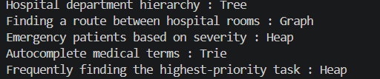
5. Observation
The selections correspond to the purposes stated in Assignment 11: Tree for hierarchy, Graph for connections/routes, Heap for priority, and Trie for prefix/autocomplete. The exact complexity depends on the implementation and data assumptions.

